**SEG Group 09 Screenshots**

**Members:**

Edward Seabrook Oscar Mariani  
Brian Yu Kelvin Chan  
Kristian Elliott

1. **Main Screen**

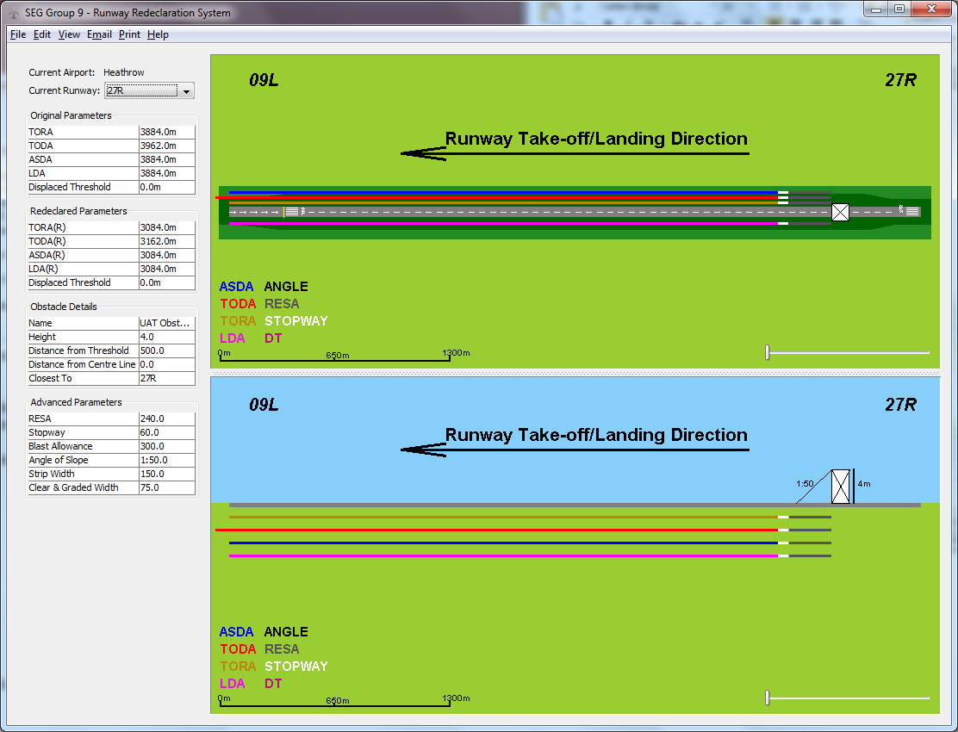

1. **Open Recent**

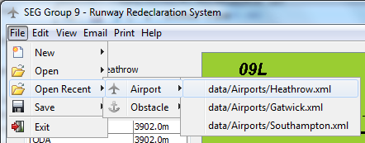

1. 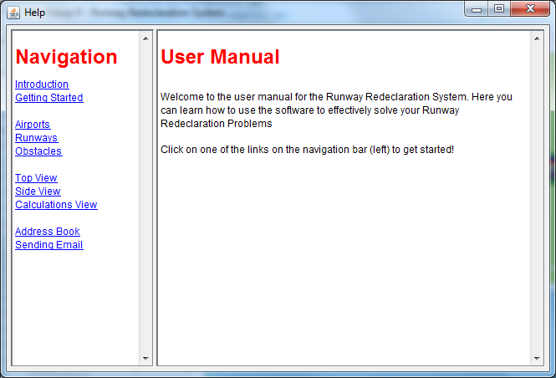**Address Book and Email**

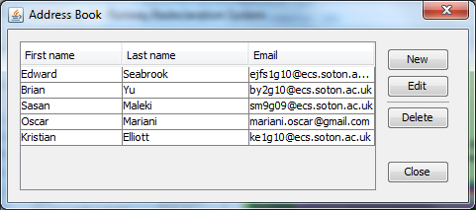

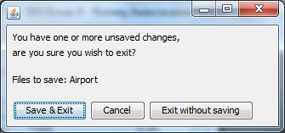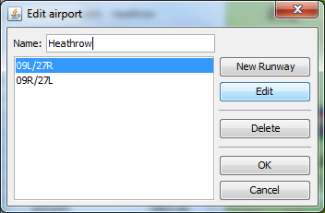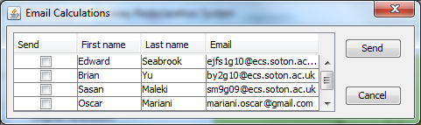

1. **User Manual**
2. **Advanced Parameters**

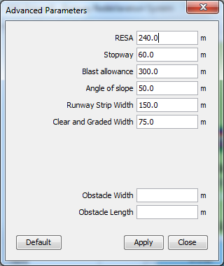

1. **Open File**

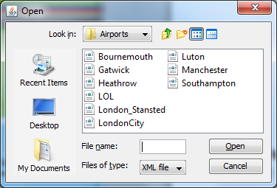

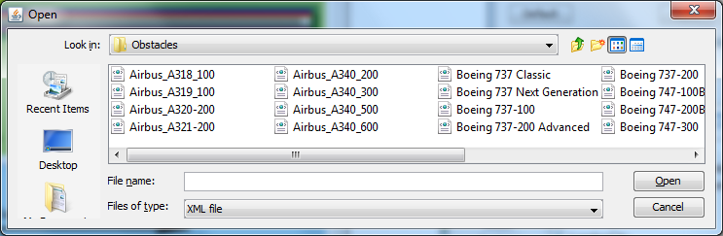

**Note: Some windows have been manipulated in size to help conserve paper**